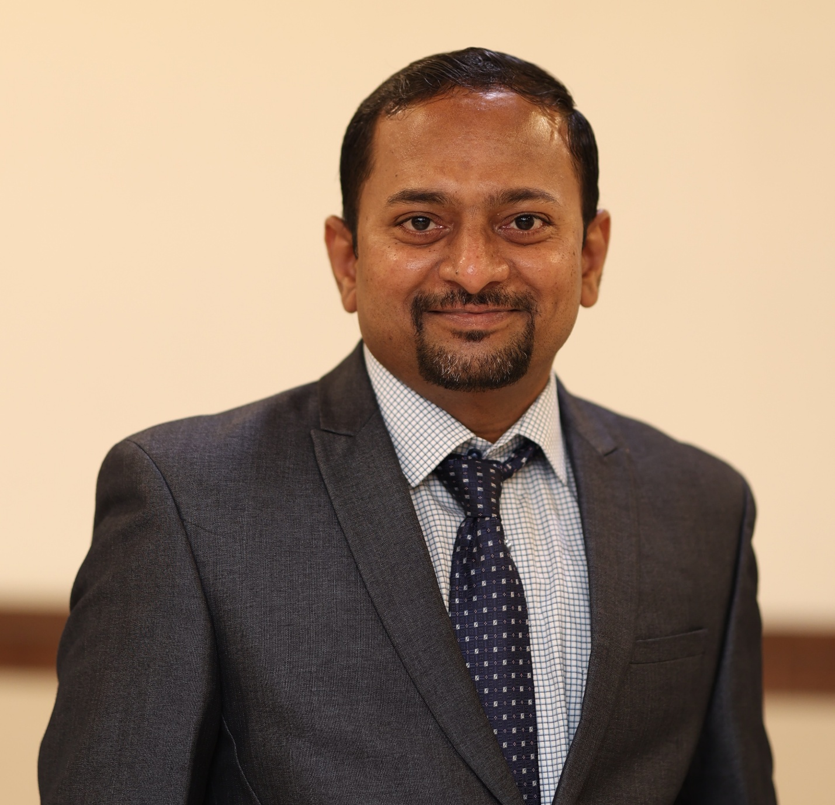Dr Manik C. Bhise
MBBS, MD (Gold Medal)
Consultant Neuropsychiatrist
Deaddiction Specialist & Sexologist
Director- Prerna Hospital LLP

Overview
Dr. Manik Changoji Bhise is a distinguished psychiatrist, academic leader, and researcher with over 20 years of experience in clinical practice, teaching, and community mental health. Currently serving as Director of Prerna Hospital LLP alongside being the Professor and Head of Psychiatry at MGM Medical College, Chhatrapati Sambhajinagar. He is a gold medalist in MD Psychiatry from MUHS Nashik. His career trajectory includes roles as Medical Officer, Tutor, Resident, and faculty positions, culminating in his current leadership role.
Dr. Bhise is a Fellow of the Indian Psychiatric Society, Indian Association for Social Psychiatry, and Indian Association of Private Psychiatrists, and has contributed as a reviewer for leading medical journals. His research has focused on rural mental health, farmers’ suicides, psychological distress, insomnia, and medical education, with numerous publications in national and international journals. He has presented widely at conferences, including ANCIPS and the World Congress of Social Psychiatry, and has been invited to speak on the Mental Health Care Act 2017 and other topics in mental health.
He has participated in clinical trials on schizophrenia, music therapy, and bioequivalence studies, serving as principal investigator. Recognized with multiple awards—including the Young Psychiatrist Fellowship (WASP) and Adarsh Shikshak Puraskar—Dr. Bhise has also engaged in community initiatives supporting survivors of farmers’ suicides. His career reflects a blend of academic excellence, clinical expertise, and social commitment.

MEMBERSHIPS & POSITIONS:
1) Member of Indian Medical Association (MAH/34930/6/948/267147/2020-21/CL)
2)Fellow Member of Indian Psychiatric Society (IPS): (1302522016)
2) Fellow Member of Indian Association for Social Psychiatry (IASP)
3) Fellow Member of Indian Association of Private Psychiatrists (01-2385-13)
4) Recipient of ‘Young Psychiatrist Fellowship’ of World Association for Social Psychiatry
5) Reviewer for Journal of Injury and Violence, Indian Journal of Psychiatry, Indian journal of
psychological medicine, Journal of TMU, Thiem Publishers, MGM Journal of medical sciences.
Awards Received
* ﻿﻿Five Gold and 2 Silver medals in MBBS course in various subjects (2000-2005)
* ﻿Young psychiatrist fellowship of World Association for Social Psychiatry (2010)
* ﻿﻿Gold Medal for 1st rank in M.D. Exam in Maharashtra State (MUHS) (2011)
* ﻿﻿Sushrut Award by Academy of Medical Sciences for best research (thesis) presentation (2011)
* ﻿﻿Dr Ramchandra Moorthy Foundation Fellowship, Bengaluru (2012)
* ﻿﻿Murugappan award of Indian Psychiatric Society (2013)
* ﻿﻿Dr Ramesh Patel poster presentation award (2014)
* Adarsh Shishak award of IMA Chhatrapati Sambhajinagar and Rotary club
Achievements:
- Principal Investigator for four clinical trials
- ﻿﻿18 Research papers in National Journals & 6 Chapters in Textbooks
- ﻿﻿Multiple Awareness articles in magazines and news papers
- Presented 14 research papers in national and international conferences
- Served as chairperson for different committees of national bodies in IPS and IAPP.

